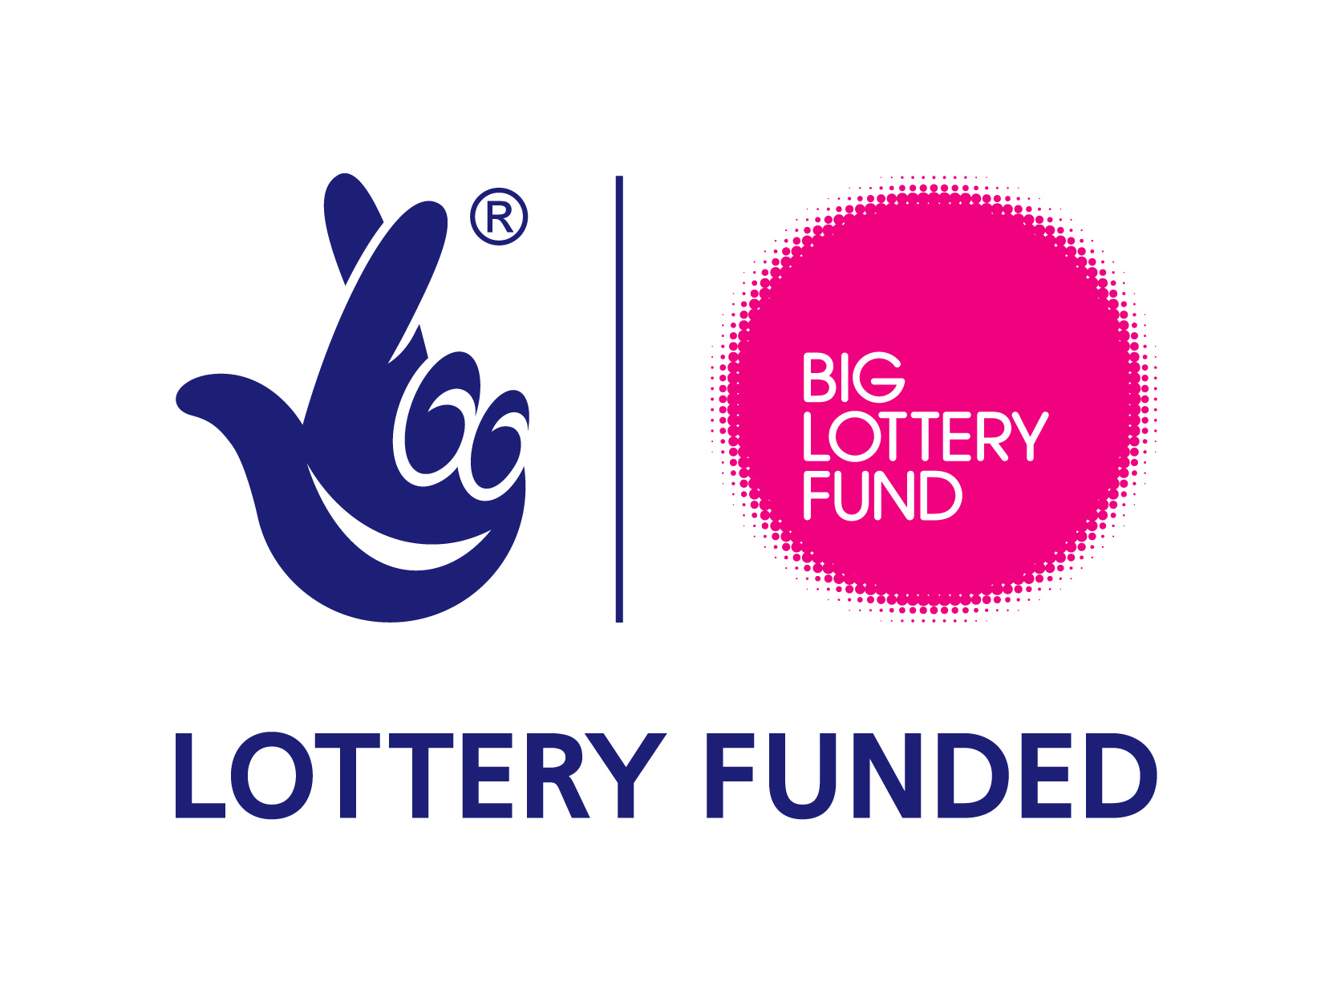
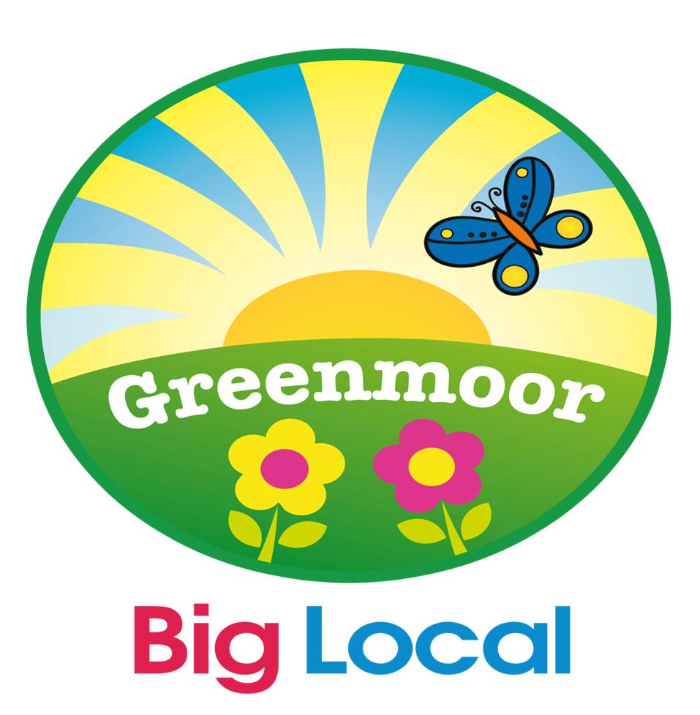
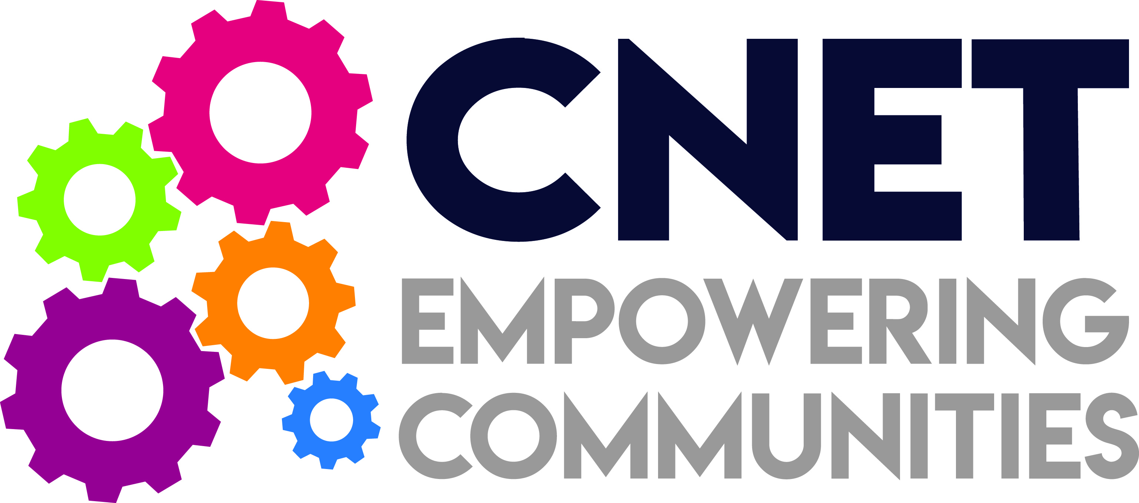

Greenmoor Big Local
Grants Programme 2018

Guidance Note

The Greenmoor Big Local Grants Programme is designed to enable organisations working in the Scholemoor and Lidget Green area to support projects that improve the quality of life for local people.
Applications are invited from local voluntary and community organisations based in the Big Local area for projects that are within the following priorities.
- Activities Involving older people
- Investing in children and young people
- Promote a cleaner, greener environment;
- Contributing to community life (stronger and safer communities)
- Activities to promote Health and Wellbeing
- Training projects for local people (volunteers)
It may fund, for example, worker time, transport, activity costs, venue hire, and a contribution to overheads.
Please explain how your project fits in with the priorities of the Community Plan that are listed above.
How much money is available?
Grants between £500 and £2000 are available per voluntary or community organisation.
The money is available for provisions across the Scholemoor and Lidget Green Big Local area and has to be spent before 31st March 2019. A full breakdown of costs with written estimates is required as part of the application process.
Who can apply?
Any voluntary or community sector organisation working and based in the Greenmoor Big Local area (or on its boarders).
You must:
- Have a commitment to providing high quality provision required in the area.
- Have a commitment to equal opportunities and diversity
- Be able to spend the grant within the specified timescale
- Be able to demonstrate how you involve people who will benefit in the design, delivery and evaluation of provision
- Priority will be given to groups/organisations applying for the first time.

Aims and Outcomes
The aim of your proposal will be consistent with the aims of Big Local to help make the area an even better place to live and support local people to get involved in contributing to this. You will be required to say how your proposal will address this.
Greenmoor fund Provision won’t fund:
- Retrospective applications
- Projects that do not benefit the residents of the Big Local area.
- Activities that have direct financial benefit to organisations’ members.
- Religious or political activities.

Application Process
You must fill in all sections of the application form.
Section 1 - Contact Details.
It is really important that this section is filled in accurately as these are the details we will use to contact you.
Section 2 - Information about your organisation/group. This helps us to understand the size and nature of your organisation. We need a commitment that you have/will develop all the policies, procedures and insurances relevant to the running of your organisation. If you need any help putting together any of these policies then we recommend you contact one of the organisations listed on the last page of this guidance note. It is your responsibility to meet
all legal and liability requirements relating to the service you are proposing to provide.
Section 3 - About the scheme you are proposing. Please provide as much information as you can about what you are proposing. Include a time plan for the implementation of the proposal giving a breakdown of start and completion dates for expenditure. Remember, this may be the only information the grants assessment panel will have about your scheme so please give as much detail as possible. Use a separate blank sheet if necessary.
Section 4 - Project Costs. We need accurate information about the costs of the scheme you are proposing. You need to include the total cost you are applying for and provide an itemised breakdown of each of the items. Although not essential, match funding for the project is encouraged (in cash, equipment, in kind, etc.) – please let us know details of any match funding proposed for the project.
Section 5 - Your Bank Details. Your bank account details are very important as any grant awarded may be paid by BACS directly into your account. Any errors will cause a delay in you receiving the funding.
Section 6 - Declaration. Please make sure the application form is signed by 2 people from your organisation’s management committee/board of trustees/directors. (Chair, Secretary or Treasurer)
Checklist - There are a number of additional pieces of information which must be submitted with your application form. Failure to include this information may delay your application or it may mean your application is not considered at all. You must include:
- A copy of your constitution/memorandum of agreement and articles of association or a set of rules
- Copy of your latest accounts showing income and expenditure, and supporting notes in respect of your activities during the months of your existence and a copy of your most recent bank statement
- A letter of support from a paid professional
Deadline for applications:
Email Applications (followed by signed hard copy), with all supporting documentation must be received at Bradford & District Community Empowerment Network Ltd (CNet), Centre for Enterprise Building,114-116 Manningham Lane, Bradford BD8 7JF- Tel: 01274 305045 - We recommend you to send in your applications as soon as possible - You can submit applications at any time until 31st March 2019 – We aim to notify you of the assessment panels’ decision within four weeks of receiving your application.
What happens next?
All applications will be considered by an assessment panel made up of Greenmoor Big Local Board Members. The panel’s decision is final.
The Grant will be allocated by Greenmoor Big Local Partnership Board and will be administered by Bradford Community Empowerment Network Limited. (CNet)
A scoring process will be used to assess the applications. Successful applicants will be notified by post within two weeks of the closing date.
Monitoring & Evaluation
At the end of the service provision a final monitoring and evaluation report will be required which will give details of your provision, activities provided and the outcome. Proof of payment, i.e. copy of receipted invoices, for all spending will be required as an audit requirement.
All financial and evaluation monitoring must be submitted to CNet within four weeks of completion of the activities.

Available support
Support is available for help with putting together an application and for advice on policies and procedures, constitutions, set of rules, etc. For further detailed advice on these please contact one of the following:
- Community Action Bradford and District (CABAD) – Clive Whittaker
Voluntary Organisation Support Officers
01274 722772
- Consortia of Ethnic Minority Organisations (COEMO) - 01274 488872

Application forms and guidelines are available from website: (a) http://Greenmoorbiglocal.org and (b) cnet.org.uk or by ringing CNet.

For more information and clarification of any of the above points please contact:
Meena Jeewa, Greenmoor Projects Coordinator, Bradford & District Community Empowerment Network Ltd (CNet), Enterprise Hub Building, 114-116 Manningham Lane, Bradford BD8 7JF
Tel: 01274 305045
Email: meena@cnet.org.uk

